IIS – Virtual directory setup

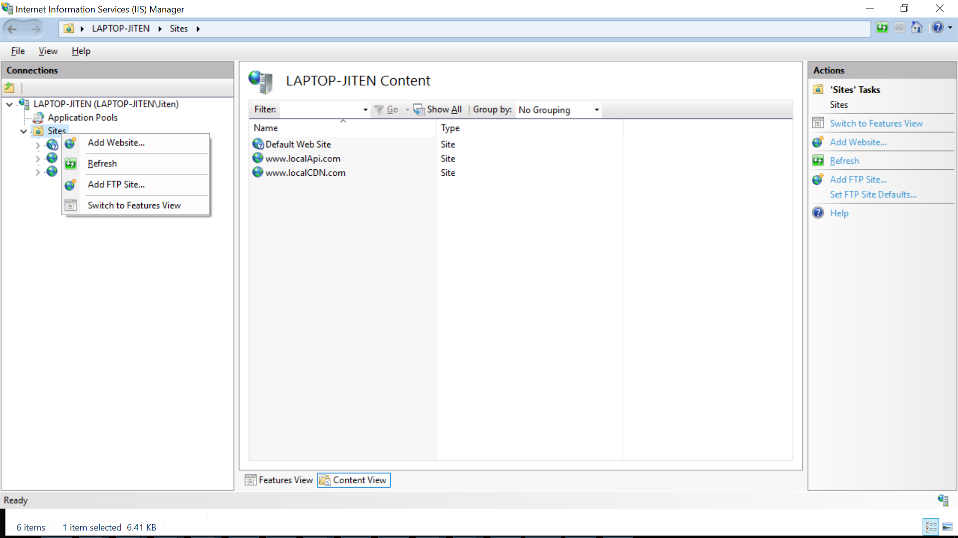

Click on Add Website

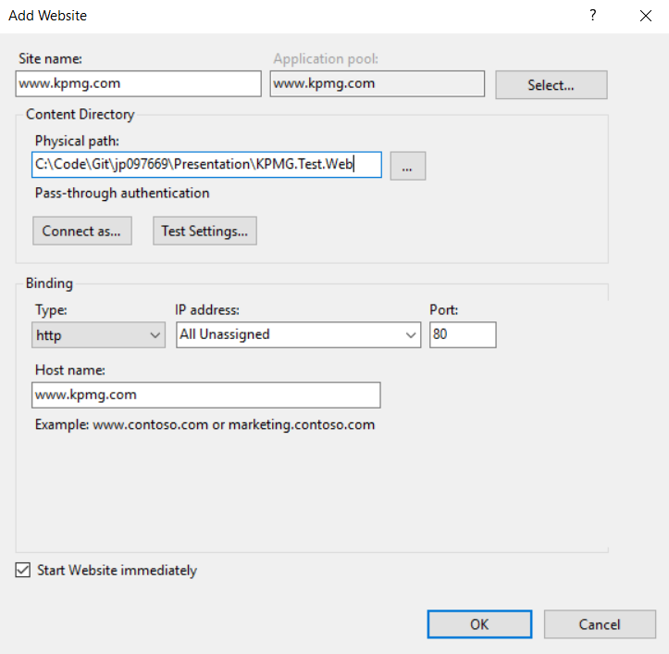

Click ok to create web site

1. Navigate to C:\Windows\System32\drivers\etc on your machine.
2. Your local drive name may be different.
3. Open hosts file.
4. Add entry in hosts file
5. 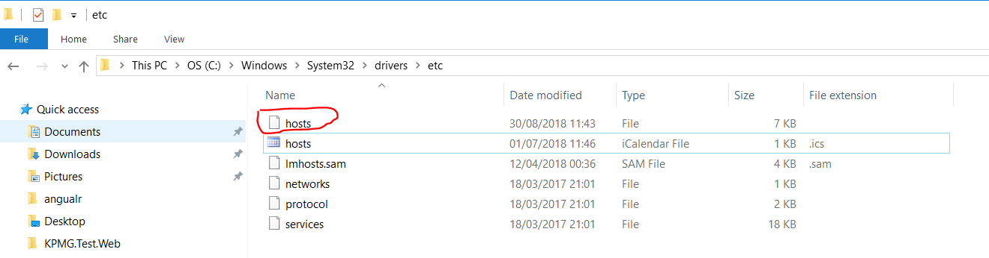
6. 127.0.0.1         [www.kpmg.com](http://www.kpmg.com)
7. 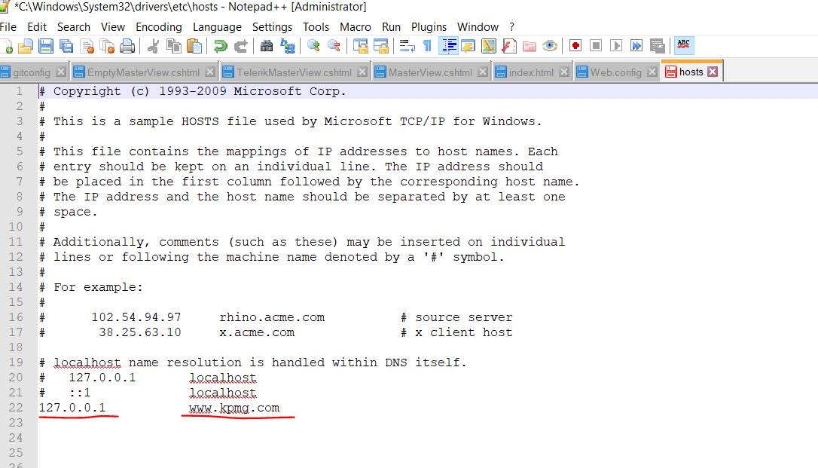
8. Save hosts file. You may need administrative rights to edit this file
9. Restart IIS
10. Open browser and enter url [www.kpmg.com](http://www.kpmg.com)